## A REPORT OF ONE MONTH TRAINING

on COMPETITIVE CODING

## at

GURU NANAK DEV ENGINEERING COLLEGE, LUDHIANA

SUBMITTED IN PARTIAL FULFILLMENT OF THE REQUIREMENT FOR THE AWARD OF THE DEGREE OF

## BACHELOR OF TECHNOLOGY

(Information Technology)



## 16/07/2022 to 16/08/2022

SUBMITTED BY:

NAME-SHIVAY UNIVERSITY ROLL NO- 1905398

DEPARTMENT OF INFORMATION TECHNOLOGY

## GURU NANAK DEV ENGINEERING COLLEGE, LUDHIANA

(An Autonomous college under UGC ACT)

## GURU NANAK DEV ENGINEERING COLLEGE, LUDHIANA CANDIDATE'S DECLARATION

I “SHIVAY BHANDARI” hereby declare that I have undertaken one month training at “Guru NanakDev Engineering College, Ludhiana” during a period from …………. to in partial

fulfilment of requirements for the award of degree of B.Tech (Electronics and Communication Engineering) at GURU NANAK DEV ENGINEERING COLLEGE, LUDHIANA. The work which is being presented in the training report submitted to Department of Electronics and Communication Engineering at GURU NANAK DEV ENGINEERING COLLEGE, LUGHIANA is an authentic record of training work.

Signature of the Student

The one-month industrial training Viva–Voce Examination of has been

held on and accepted.

Signature of Internal Examiner Signature of External Examiner

## ABSTRACT

During the training, I have been taught about competitive coding in which I have learned basic data structures and algorithms and also learned how to implement all these concepts with the help of programming language i.e. C++ or Python. Here I have revised about basic C++ programming concepts i.e. functions, pointers, OOPS, reference variables to implement the concept of data structure and algorithm. In data structure, I have learned about Array, Linked List, Stack, Queues and Hashing. In algorithm section, I have learned about analyse and design of algorithm, asymptotic notation, basic recursion, searching and sorting. All these concepts are backbone to develop any software and build a career in software development in IT sector.

## ACKNOWLEDGEMENT

I am highly grateful to the Dr. Sehijpal Singh, Principal, Guru Nanak Dev Engineering College (GNDEC), Ludhiana, for providing this opportunity to carry out the one-month training on

Competitive Coding. The Encouragement received form Dr. Kulvinder Singh Mann, Head, Department of Information Technology , GNDEC Ludhiana has been of great help in carrying the present work and is acknowledged with reverential thanks.

I humbly acknowledge my gratitude to T&P department as well as the coordinator Prof. Kuldeepak Singh and other faculty members of IT department also for helping me, answering my doubts all along and guiding me. They helped me right from the beginning of to the end in every aspect. I am sincerely grateful to all of them for sharing their truthful and illuminating views on a number of issues related to the training.

Last, but not the least, my thanks are also due to all others who remained behind the scene but whose work has been consulted and referred to in this training.

CONTENTS

Candidate Declaration 2

Abstract 3

Acknowledgement 4

List of Figures 6

CHAPTER-1 (Introduction to Programming with CPP) 7-14

* 1. Functions 7-10
  2. Pointers 10-12
  3. Oops Concepts 12-14
  4. OOPS and Pointers 14

CHAPTER-2 (Algorithm Fundamentals and basic operations) 15-22

* 1. Introduction to DS and algorithm 15-16
  2. Analyze and Design algorithms 16
  3. Asymptotic notation 17-20
  4. Basic recursion algorithms on memory level 21-22

CHAPTER-3 (Introduction to Linear Data Structure) 23-28

* 1. Array and Linked List 23-26
  2. Stacks 26-27
  3. Queues 28

CHAPTER -4 (Hash and RTP) 29-34

* 1. Notion of Hashing and Collision 29-30
  2. Hash Functions – properties, simple function 30-32
  3. Methods of collision handling 32-33
  4. RTP 34

References 36

# LIST OF FIGURES

1. Functions 7
2. Pointers 10
3. Oops Concepts 12
4. Introduction to DS and algorithm 15
5. Analyze and Design algorithms 16
6. Asymptotic notation… 17
7. Basic recursion algorithms on memory level 21
8. Array and Linked List 23
9. Stacks 26
10. Queues 28
11. Notion of Hashing and Collision 29
12. Hash functions 30
13. Methods of collision handling 32
14. RTP 34

# CHAPTER – 1

## INTRODUCTION TO PROGRAMMING WITH CPP

* 1. FUNCTIONS

A function in C++ refers to a group of statements that takes input, processes it, and returns an output. The idea behind a function is to combine common tasks that are done repeatedly. If you have different inputs, you will not write the same code again. You will simply call the function with a different set of data called parameters.

Each C++ program has at least one function, the main() function. You can divide your code into different functions. This division should be such that every function does a specific task.

Need of functions - There are numerous benefits associated with the use of functions. These include:

* + - Each function puts related code together. This makes it easier for programmers to understand code.
    - Functions make programming easier by eliminating code repetition.
    - Functions facilitate code reuse. You can call the same function to perform a task at different sections of the program or even outside the program.

There are two basic types of function:-

* + - Built in function
    - User defined function

Built in function - These functions are part of the compiler package. These are part of standard library made available by the compiler. For example, exit(), sqrt(), pow(), strlen() etc. are library functions (built-in functions). Built-in functions help you, to use function without declaring and defining it. To use built-in functions in a program, you have to only include that header file where the required function is defined. Here is an example. This program uses builtin function named strlen() of string.h header file to find the length of the string.

#include<iostream.h> #include<string.h> #include<conio.h> void main()

{ clrscr(); char str[80]; cout<<"Enter any string (line):\n";

cin.getline(str, 80); int len = strlen(str); cout<<"\nLength of the string is: "<<len; getch();

}

User defined function -The user-defined functions are created by you i.e., the programmer. These functions are created as per requirements of your program. Here is an example, demonstrating user-defined functions in C++.

#include<iostream.h>

#include<conio.h> void start_msg(void); //

function declaration void main()

{ clrscr(); start_msg(); // function calling int num; cout<<"Enter a number: "; cin>>num; cout<<"You entered: "<<num;

getch();

}

void start_msg(void) // function definition

{ cout<<"Welcome to gndec ludhiana\n"; cout<<"This is C++ Function Types Tutorial\n\n";

}

Function Definition - The general form of a C++ function definition is as follows −

return_type function_name( parameter list ) { body of the function

}

A C++ function definition consists of a function header and a function body. Here are all the parts of a function −

* + - * Return Type − A function may return a value. The return_type is the data type of the value the function returns. Some functions perform the desired operations without returning a value. In this case, the return_type is the keyword void.
      * Function Name − This is the actual name of the function. The function name and the parameter list together constitute the function signature.
      * Parameters − A parameter is like a placeholder. When a function is invoked, you pass a value to the parameter. This value is referred to as actual parameter or argument. The parameter list refers to the type, order, and number of the parameters of a function. Parameters are optional; that is, a function may contain no parameters.
      * Function Body − The function body contains a collection of statements that define what the function does.

## POINTERS

Pointers are symbolic representations of addresses. They enable programs to simulate call- byreference as well as to create and manipulate dynamic data structures. Iterating over elements in arrays or other data structures is one of the main use of pointers.

The address of the variable you’re working with is assigned to the pointer variable that points to the same data type (such as an int or string).

Syntax: datatype

*var_name;

int *ptr; // ptr can point to an address which holds int data

How to use a pointer?

* Define a pointer variable
* Assigning the address of a variable to a pointer using the unary operator (&) which returns the address of that variable.
* Accessing the value stored in the address using unary operator (*) which returns the value of the variable located at the address specified by its operand.

#include <bits/stdc++.h> using namespace std; void geeks()

{ int var = 20;

// declare pointer variable int* ptr;

// note that data type of ptr and var must be same ptr

= &var;

// assign the address of a variable to a pointer cout << "Value at ptr = " << ptr << "\n"; cout

<< "Value at var = " << var << "\n"; cout << "Value at *ptr = " << *ptr << "\n";

}

// Driver program int main()

{

geeks();

return 0;

}

## OBJECT ORIENTED PROGRAMMING (OOPS)

OOPs, or Object-oriented programming is an approach or a programming pattern where the programs are structured around objects rather than functions and logic. It makes the data partitioned into two memory areas, i.e., data and functions, and helps make the code flexible and modular. Object-oriented programming mainly focuses on objects that are required to be manipulated. In OOPs, it can represent data as objects that have attributes and functions. There are some basic concepts that act as the building blocks of OOPs.

* + - Classes & Objects
    - Abstraction
    - Encapsulation
    - Inheritance
    - Polymorphism

1.3.3 Object: An Object can be defined as an entity that has a state and behaviour, or in other words, anything that exists physically in the world is called an object. It can represent a dog, a person, a table, etc.

For example, “Dog” is a real-life Object, which has some characteristics like color, Breed, Bark, Sleep, and Eats.

* + 1. Classes: Class can be defined as a blueprint of the object. It is basically a collection of objects which act as building blocks. A class contains data members (variables) and member functions. These member functions are used to manipulate the data members inside the class.

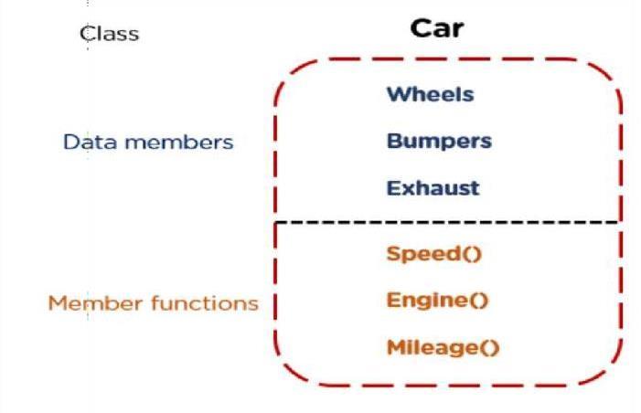

Figure 1 Class example

* + 1. Abstraction: Abstraction helps in the data hiding process. It helps in displaying the essential features without showing the details or the functionality to the user. It avoids unnecessary information or irrelevant details and shows only that specific part which the user wants to see.
    2. Encapsulation: The wrapping up of data and functions together in a single unit is known as encapsulation. It can be achieved by making the data members' scope private and the member function’s scope public to access these data members. Encapsulation makes the data non- accessible to the outside world.
    3. Inheritance: Inheritance is the process in which two classes have an is-a relationship among each other and objects of one class acquire properties and features of the other class. The class which inherits the features is known as the child class, and the class whose features it inherited is called the parent class. For example, Class Vehicle is the parent class, and Class Bus, Car, and Bike are child classes.
    4. Polymorphism: Polymorphism means many forms. It is the ability to take more than one form. It is a feature that provides a function or an operator with more than one definition. It can be implemented using function overloading, operator overload, function overriding, virtual function.

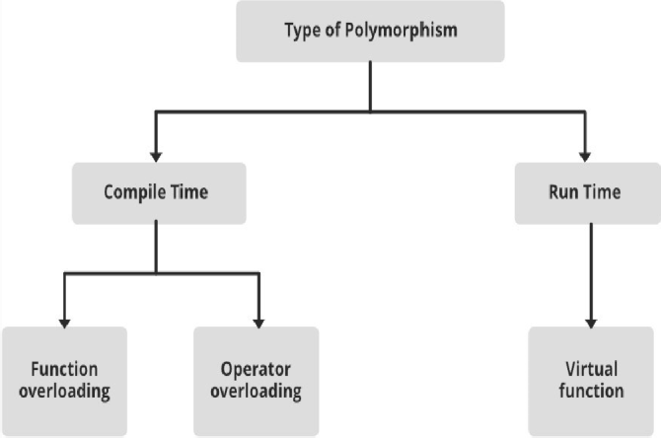

Figure 2 Type of Polymorphism

* 1. POINTERS AND REFERENCES

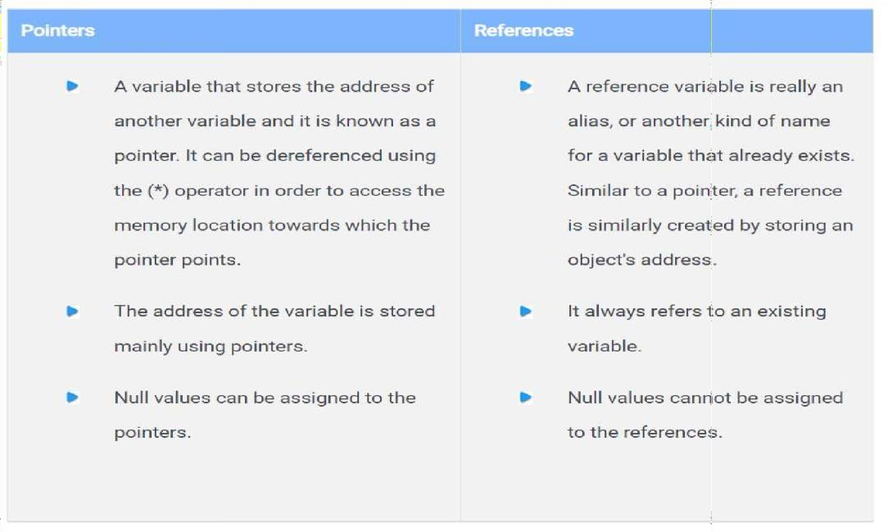

# CHAPTER 2

ALGORITHM FUNDAMENTALS AND BASIC OPERATIONS

## Introduction to DS and algorithms

What is Data Structure and Algorithms?

A data structure is defined as a particular way of storing and organizing data in our devices to use the data efficiently and effectively. The main idea behind using data structures is to minimize the time and space complexities. An efficient data structure takes minimum memory space and requires minimum time to execute the data.

Algorithm is defined as a process or set of well-defined instructions that are typically used to solve a particular group of problems or perform a specific type of calculation. To explain in simpler terms, it is a set of operations performed in a step-by-step manner to execute a task.

Applications of Data Structure and Algorithms

Algorithm is a step-by-step procedure, which defines a set of instructions to be executed in a certain order to get the desired output. Algorithms are generally created independent of underlying languages, i.e. an algorithm can be implemented in more than one programming language.

From the data structure point of view, following are some important categories of algorithms −

* Search − Algorithm to search an item in a data structure.
* Sort − Algorithm to sort items in a certain order.
* Insert − Algorithm to insert item in a data structure.
* Update − Algorithm to update an existing item in a data structure.
* Delete − Algorithm to delete an existing item from a data structure

## Analyze and design algorithms

What is meant by Algorithm Analysis?

Algorithm analysis is an important part of computational complexity theory, which provides theoretical estimation for the required resources of an algorithm to solve a specific computational problem. Analysis of algorithms is the determination of the amount of time and space resources required to execute it.

Algorithms are often quite different from one another, though the objective of these algorithms are the same. For example, we know that a set of numbers can be sorted using different algorithms. Number of comparisons performed by one algorithm may vary with others for the same input. Hence, time complexity of those algorithms may differ. At the same time, we need to calculate the memory space required by each algorithm.

Analysis of algorithm is the process of analyzing the problem-solving capability of the algorithm in terms of the time and size required (the size of memory for storage while implementation). However, the main concern of analysis of algorithms is the required time or performance. Generally, we perform the following types of analysis −

* + - Worst-case − The maximum number of steps taken on any instance of size
    - Best-case − The minimum number of steps taken on any instance of size
    - Average case − An average number of steps taken on any instance of size
    - Amortized − A sequence of operations applied to the input of size averaged over time.
  1. Asymptotic notation:

Asymptotic notations are the mathematical notations used to describe the running time of an algorithm when the input tends towards a particular value or a limiting value.

For example: In bubble sort, when the input array is already sorted, the time taken by the algorithm is linear i.e. the best case.

But, when the input array is in reverse condition, the algorithm takes the maximum time (quadratic) to sort the elements i.e. the worst case.

When the input array is neither sorted nor in reverse order, then it takes average time. These durations are denoted using asymptotic notations.

There are mainly three asymptotic notations:

1. Big-O notation
2. Omega notation
3. Theta notation
   * 1. Big-O notation:

* Big O notation is an asymptotic notation that measures the performance of an algorithm by simply providing the order of growth of the function.
* This notation provides an upper bound on a function which ensures that the function never grows faster than the upper bound. So, it gives the least upper bound on a function so that the function never grows faster than this upper bound.

It is the formal way to express the upper boundary of an algorithm running time. It measures the worst case of time complexity or the algorithm's longest amount of time to complete its operation. It is represented as shown below:

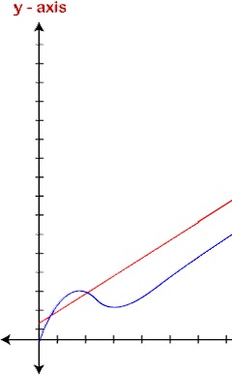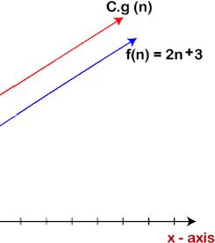

The idea of using big o notation is to give an upper bound of a particular function, and eventually it leads to give a worst-time complexity. It provides an assurance that a particular function does not behave suddenly as a quadratic or a cubic fashion, it just behaves in a linear manner in a worst-case.

* + 1. Omega notation
       - It basically describes the best-case scenario which is opposite to the big o notation.
       - It is the formal way to represent the lower bound of an algorithm's running time. It measures the best amount of time an algorithm can possibly take to complete or the best-case time complexity.
       - It determines what the fastest time that an algorithm can run is.

If we required that an algorithm takes at least certain amount of time without using an upper bound, we use big- Ω notation i.e. the Greek letter "omega". It is used to bind the growth of

running time for large input size.

If f(n) and g(n) are the two functions defined for positive integers,

then f(n) = Ω (g(n)) as f(n) is Omega of g(n) or f(n) is on the order of g(n)) if there exists constants c and no such that: f(n)>=c.g(n) for all n≥no and c>0

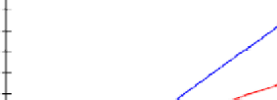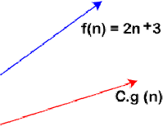

As we can see in the above figure that g(n) function is the lower bound of the f(n) function when the value of c is equal to 1. Therefore, this notation gives the fastest running time. But, we are not more interested in finding the fastest running time, we are interested in calculating the worst-case scenarios because we want to check our algorithm for larger input that what is the worst time that it will take so that we can take further decision in the further process.

* + 1. Theta notation
       - The theta notation mainly describes the average case scenarios.
       - It represents the realistic time complexity of an algorithm. Every time, an algorithm does not perform worst or best, in real-world problems, algorithms mainly fluctuate between the worst-case and best-case, and this gives us the average case of the algorithm.
       - Big theta is mainly used when the value of worst-case and the best-case is same.
       - It is the formal way to express both the upper bound and lower bound of an algorithm running time.

Let's understand the big theta notation mathematically:

Let f(n) and g(n) be the functions of n where n is the steps required to execute the program then: f(n)= θg(n)

The above condition is satisfied only if when

c1.g(n)<=f(n)<=c2.g(n)

where the function is bounded by two limits, i.e., upper and lower limit, and f(n) comes in between. The condition f(n)= θg(n) will be true if and only if c1.g(n) is less than or equal to f(n) and c2.g(n) is greater than or equal to f(n). The graphical representation of theta notation is given below:

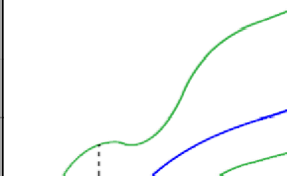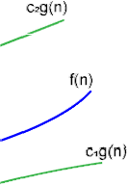

## 2.4. Basic recursion algorithms on memory level.

What is Recursion?

The process in which a function calls itself directly or indirectly is called recursion and the corresponding function is called a recursive function. Using a recursive algorithm,

certain problems can be solved quite easily. Examples of such problems are Towers of Hanoi (TOH), Inorder/Preorder/Postorder Tree Traversals, DFS of Graph, etc. A recursive function solves a particular problem by calling a copy of itself and solving smaller subproblems of the original problems. Many more recursive calls can be generated as and when required. It is essential to know that we should provide a certain case in order to terminate this recursion process. So we can say that every time the function calls itself with a simpler version of the original problem.

Need of Recursion

Recursion is an amazing technique with the help of which we can reduce the length of our code and make it easier to read and write. It has certain advantages over the iteration technique which will be discussed later. A task that can be defined with its similar subtask, recursion is one of the best solutions for it. For example; The Factorial of a number.

Memory Allocation in Recursion

When any function is called from main(), the memory is allocated to it on the stack. A recursive function calls itself, the memory for a called function is allocated on top of memory allocated to the calling function and a different copy of local variables is created for each function call. When the base case is reached, the function returns its value to the function by whom it is called and memory is de-allocated and the process continues.

When a recursive function is called for the first time, a space is set aside in the memory to execute this call and the function body is executed. Then a second call to a function is made; again a space is set for this call, and so on. In other words, memory spaces for each function call are arranged in a stack. Each time a function is called; its memory

area is placed on the top of the stack and is removed when the execution of the call is completed.

# CHAPTER 3

INTRODUCTION TO LINEAR DATA STRUCTURES

It is a type of data structure where the arrangement of the data follows a linear trend. The data elements are arranged linearly such that the element is directly linked to its previous and the next elements. As the elements are stored linearly, the structure supports single-level storage of data. And hence, traversal of the data is achieved through a single run only.

## ARRAY

The array is that type of structure that stores homogeneous elements at memory locations which are contiguous. The same types of objects are stored sequentially in an array. The main idea of an array is that multiple data of the same type can be stored together. Before storing the data in an array, the size of the array has to be defined. Any element in the array can be accessed or modified and the elements stored are indexed to identify their locations.An array can be explained with the help of a simple example of storing the marks for all the students in a class. Suppose there are 20 students, then the size of the array has to be mentioned as 20. Marks of all the students can then be stored in the created array without the need for creating separate variables for marks for every student. Simple traversal of the array can lead to the access of the elements.

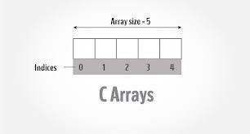

Figure 3.1 Array

## CODE :

#include <iostream>

using namespace std;

int main() {

int arr[5]={10, 0, 20, 0, 30};

for (int i = 0; i < 5; i++) {

cout<<arr[i]<<"\n";

}

}

LINKED LIST: The linked list is that type of data structure where separate objects are stored sequentially. Every object stored in the data structure will have the data and a reference to the next object. The last node of the linked list has a reference to null. The first element of the linked list is known as the head of the list. There are many differences between a linked list to the other types of data structures. These are in terms of memory allocation, the internal structure of the data structure, and the operations carried on the linked list.

Getting to an element in a linked list is a slower process compared to the arrays as the indexing in an array helps in locating the element. However, in the case of a linked list, the process has

to start from the head and traverse through the whole structure until the desired element is reached. In contrast to this, the advantage of using linked lists is that the addition or deletion of elements at the beginning can be done very quickly. There are three types of linked lists:

* Single Linked List: This type of structure has the address or the reference of the next node stored in the current node. Therefore, a node which at the last has the address and reference as a NULL. Example: A->B->C->D->E->NULL.

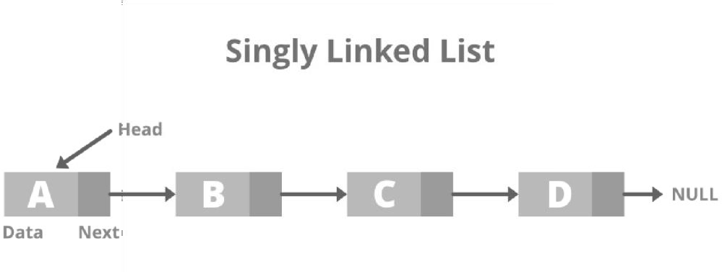

Figure 3.2 Single Linked List

A Double Linked List: As the name suggests, each node has two references associated with it. One reference directs to the previous node while the second reference points to the next node. Traversal is possible in both directions as reference is available for the previous nodes. Also, explicit access is not required for deletion. Example: NULL<A<-

>B<->C<->D<->E->NULL.

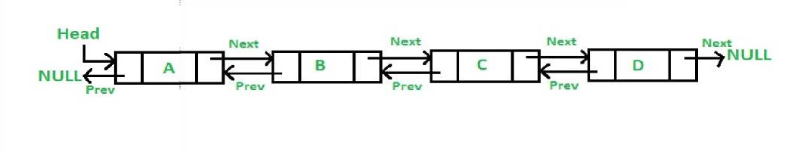

Figure 3.3 Double Linked List

* Linked List circular: The nodes in a circular linked list are connected in a way that a circle is formed. As the linked list is circular there is no end and hence no NULL. This type of linked list can follow the structure of both singly or doubly. There is no specific starting node and any node from the data can be the starting node. The reference of the last node points towards the first node. Example: A->B->C->D->E.

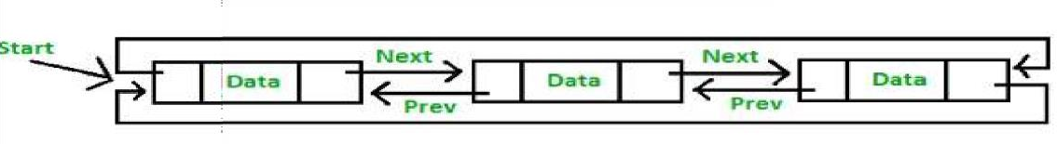

Figure 3.5 Linked List Circular

* 1. STACKS: The stack is another type of structure where the elements stored in the data structure follow the rule of LIFO (last in, first out) or FILO (First In Last Out). Two types of operations are associated with a stack i.e. push and pop. Push is used when an element has to be added to the collection and pop is used when the last element has to be removed from the collection. Extraction can be carried out for only the last added element.

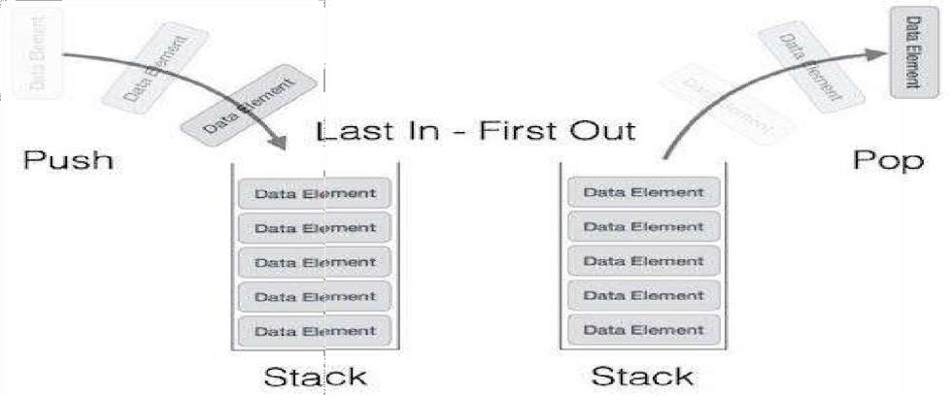

Figure 3.6 Stacks

CODE TO PERFORM PUSH AND POP FUNCTIONS:

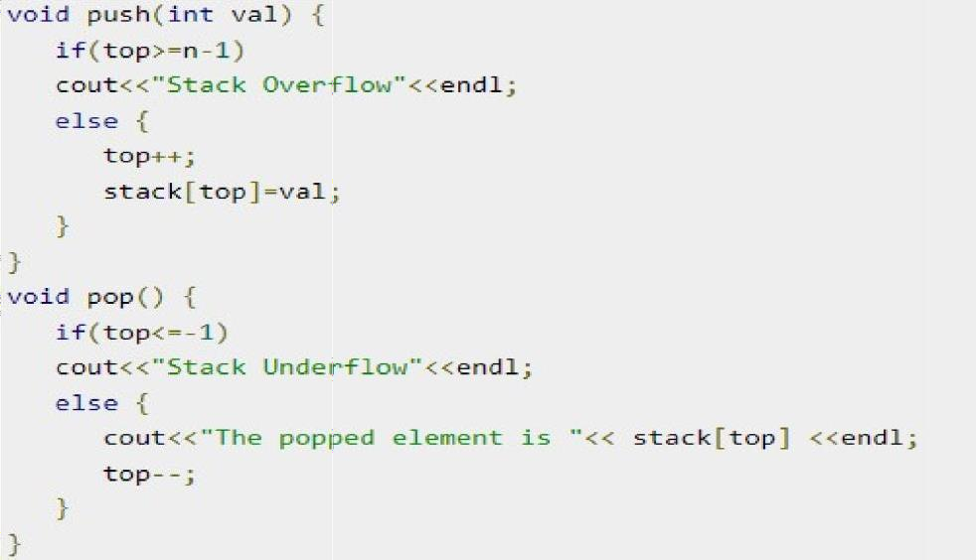

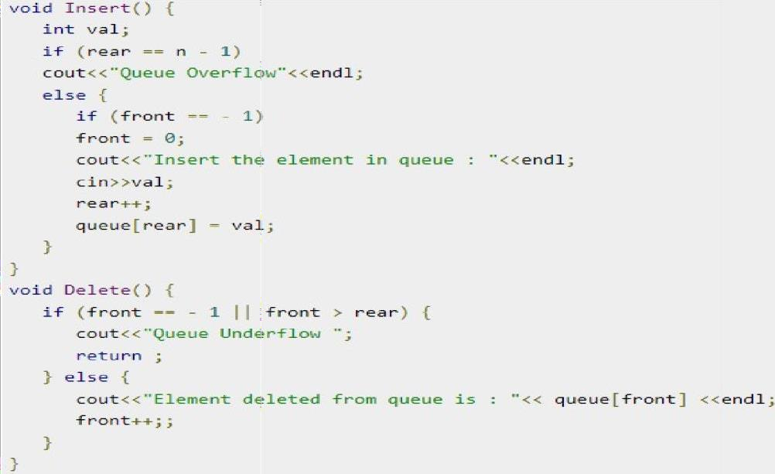

* 1. Queue: Queue is the type of data structure where the elements to be stored follow the rule of First In First Out (FIFO). The particular order is followed for performing the required operations over the elements. The difference of a queue from that of a stack lies in the removal of an element, where the most recently added object is removed first in a stack.

Whereas, in the case of a queue, the element that was added first is removed first. Both the end of the data structure is used for the insertion and the removal of data. The two main operations governing the structure of the queue are enqueue, and dequeue. Enqueue refers to the process where inserting an element is allowed to the collection of data and dequeue refers to the process where removal of elements is allowed, which is the first element in the queue in this case. Example of the queue: Similar to those queues made while waiting for the bus or anywhere, the data structure too follows the same pattern. We can imagine a person waiting for the bus and standing at the first position as the person that came to the queue first. This person will be the first one who will get onto a bus, i.e. exit the queue. Queues are applied when multiple users are sharing the same resources and they have to be served on the basis of who has come first on the server.

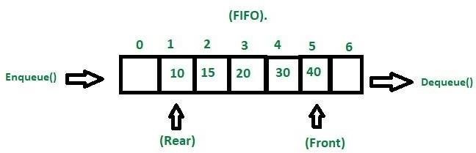

Figure 3.7 Queue

In the above program, the function Insert() inserts an element into the queue. If the rear is equal to n-1, then the queue is full and overflow is displayed. If front is -1, it is incremented by 1. Then rear is incremented by 1 and the element is inserted in index of rear. In the function Delete(), if there are no elements in the queue then it is underflow condition. Otherwise the element at front is displayed and front is incremented by one.

# CHAPTER 4 HASH TABLE

## Notion of Hashing and Collision

Hashing: Hashing is a technique of mapping a large set of arbitrary data to tabular indexes using a hash function. It is a method for representing dictionaries for large datasets. This is usually represented by a shorter, fixed-length value or key that represents and makes it easier to find or employ the original string. The most popular use for hashing is the implementation of hash tables. Hashing is a popular technique for storing and retrieving data as fast as possible. The main reason behind using hashing is that it gives optimal results as it performs optimal searches.

Why to use Hashing? : If you observe carefully, in a balanced binary search tree, if we try to search , insert or delete any element then the time complexity for the same is O(logn). Now there might be a situation when our applications want to do the same operations in a faster way

i.e. in a more optimized way and here hashing comes into play. In hashing, all the above operations can be performed in O(1) i.e. constant time. It is important to understand that the worst case time complexity for hashing remains O(n) but the average case time complexity is O(1).

Let a hash function H(x) maps the value at the index x%10 in an Array. For example if the list of values is [11,12,13,14,15] it will be stored at positions {1,2,3,4,5} in the array or Hash table respectively.

Collision:

a hash collision or clash is when two pieces of data in a hash table share the same hash value. The hash value in this case is derived from a hash function which takes a data input and returns a fixed length of bits.

Although hash algorithms have been created with the intent of being collision resistant, they can still sometimes map different data to the same hash (by virtue of the pigeonhole principle). Malicious users can take advantage of this to mimic, access, or alter data.

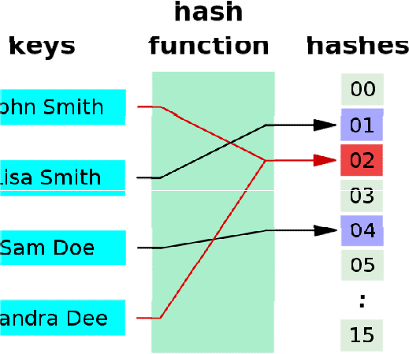

Figure 4.1 Hash Collision

## Hash Functions

A hash function is any function that can be used to map data of arbitrary size to fixed-size values. A hash function takes a group of characters (called a key) and maps it to a value of a certain length (called a hash value or hash). The hash value is representative of the original string of characters, but is normally smaller than the original. Hashing is used with a database to enable items to be retrieved more quickly. Hashing can also be used in the encryption and

decryption of digital signatures. The hash function transforms the digital signature, then both the hash value and signature are sent to the receiver. The receiver uses the same hash function

to generate the hash value and then compares it to that received with the message. If the hash values are the same, it is likely that the message was transmitted without errors.

One example of a hash function is called folding. This takes an original value, divides it into several parts, then adds the parts and uses the last four remaining digits as the hashed value or key.

Another example is called digit rearrangement. This takes the digits in certain positions of the original value, such as the third and sixth numbers, and reverses their order. It then uses the number left over as the hashed value.

A good hash function should have the following properties:

1. Efficiently computable.
2. Should uniformly distribute the keys (Each table position equally likely for each key)

The two heuristic methods are hashing by division and hashing by multiplication which are as follows:

1. The mod method:

* In this method for creating hash functions, we map a key into one of the slots of table by taking the remainder of key divided by table_size. That is, the hash function is h(key) = key mod table_size

i.e. key % table_size

* Suppose r = 256 and table_size = 17, in which r % table_size i.e. 256 % 17 = 1.

So for key = 37599, its hash is

37599 % 17 = 12

But for key = 573, its hash function is also 573 % 17 = 12

1. The multiplication method:
   * In multiplication method, we multiply the key k by a constant real number c in the range 0 < c < 1 and extract the fractional part of k * c.
   * Then we multiply this value by table_size m and take the floor of the result. It can be represented as h(k) = floor (m * (k * c mod 1))

or

h(k) = floor (m * frac (k * c))

## Method of Collision Handling

There are mainly two methods to handle collision:

* Separate Chaining
* Open Addressing

Separate Chaining: The idea behind separate chaining is to implement the array as a linked list called a chain. Separate chaining is one of the most popular and commonly used techniques in order to handle collisions.

The linked list data structure is used to implement this technique. So what happens is, when multiple elements are hashed into the same slot index, then these elements are inserted into a singly-linked list which is known as a chain.

Here, all those elements that hash into the same slot index are inserted into a linked list. Now, we can use a key K to search in the linked list by just linearly traversing. If the intrinsic key for any entry is equal to K then it means that we have found our entry. If we have reached the end

of the linked list and yet we haven’t found our entry then it means that the entry does not exist. Hence, the conclusion is that in separate chaining, if two different elements have the same hash value then we store both the elements in the same linked list one after the other.

Example: Let us consider a simple hash function as “key mod 7” and a sequence of keys as 50, 700, 76, 85, 92, 73, 101

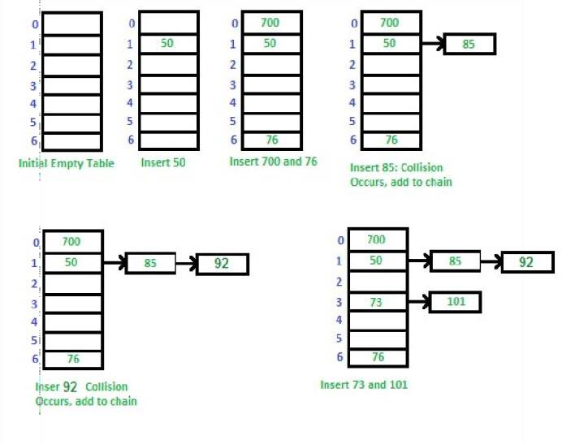

Open Addressing:

Like separate chaining, open addressing is a method for handling collisions. In Open Addressing, all elements are stored in the hash table itself. So at any point, the size of the table must be greater than or equal to the total number of keys (Note that we can increase table size by copying old data if needed). This approach is also known as closed hashing. This entire procedure is based upon probing. We will understand the types of probing ahead:

* Insert(k): Keep probing until an empty slot is found. Once an empty slot is found, insert k.
* Search(k): Keep probing until the slot’s key doesn’t become equal to k or an empty slot is reached.
* Delete(k): Delete operation is interesting. If we simply delete a key, then the search may fail. So slots of deleted keys are marked specially as “deleted”.

The insert can insert an item in a deleted slot, but the search doesn’t stop at a deleted slot.

## Real Time Transport Protocol (RTP):

A protocol is designed to handle real-time traffic (like audio and video) of the Internet, is known as Real Time Transport Protocol (RTP). RTP must be used with UPD. It does not have any delivery mechanism like multicasting or port numbers. RTP supports different formats of files like MPEG and MJPEG. It is very sensitive to packet delays and less sensitive to packet loss.

* + 1. Applications of RTP:
       - RTP mainly helps in media mixing, sequencing, and time stamping.
       - Voice over Internet Protocol (VoIP)
       - Video Teleconferencing over Internet.
       - Internet Audio and video streaming.

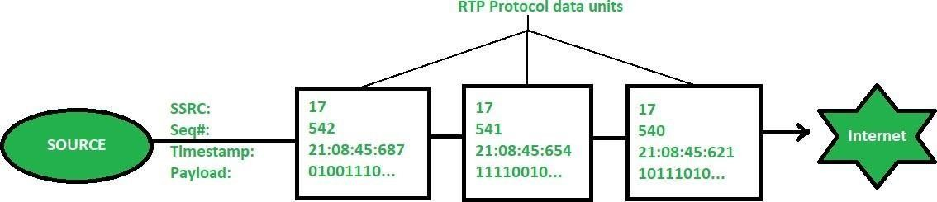

Figure 4.2 RTP

# REFERENCES

1. https://[www.geeksforgeeks.org/](http://www.geeksforgeeks.org/) …accessed on Aug. 2022.
2. https://[www.programiz.com/](http://www.programiz.com/) ….accessed on Sept. 2022
3. https://[www.tutorialspoint.com/](http://www.tutorialspoint.com/) …accessed on Oct. 2022